**Chapter 2. Lab Assignment (20 points)**

**Name: ____Jaime Bonilla___**

**Task 1.** This is a small corporate network installed in a building (the following Figure). It has three switches connected to the border router with built-in firewall capacity to prevent intrusions from the Internet. Disregarding the connection between the firewall router and the Internet: (**7 points**)

1. How many subnetworks are there? ____3__ (**1 point**)
2. If PC1 sends a message to the email server, is this inter-networking? ____no__ (**1 point**)
3. Detail the path from PC1 to email server. ___The path to PC1 is to the switch and then from the switch to the email server___ (**1 point**)
4. If PC1 sends a message to the file server, is this inter-networking? __Yes, it would be considered inter-networking because it goes from the switch to the router____ (**1 point**)
5. Detail the path from PC1 to the file server. _____PC1 to Switch to Firewall router to Switch to File Server. _ (**1 point**)
6. What is the intermediary device used for intra-networking? ___switch___ (**1 point**)
7. What is the intermediary device used for inter-networking? __Router and Switch____ (**1 point**)

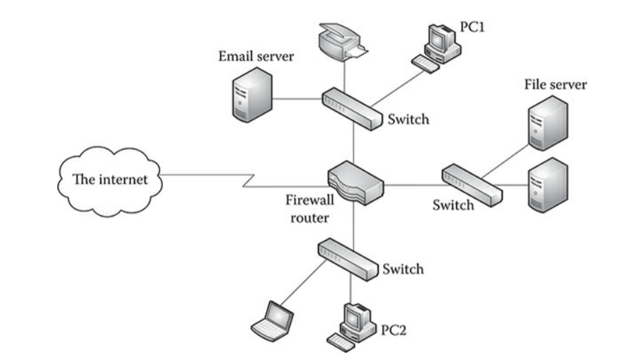

**Task 2.** Based on our in-class discussion, write down the most interesting/funniest/easiest acronym creation of the hybrid standard architectures. **(1 point)**

**ATIDP And Today I’m Desiring Pizza**

**Task 3.** This is a hand-on task. You need to download wireshark software from [www.wireshark.org](http://www.wireshark.org). Read the instruction document to be familiar with wireshark. Capture and observe packets between your own host and servers. Answer the following questions. **(12 points)**

1. Download wireshark software from [www.wireshark.org](http://www.wireshark.org). Install it on your own computer. Post the very first screenshot of your wireshark welcome page. (**1 point**)

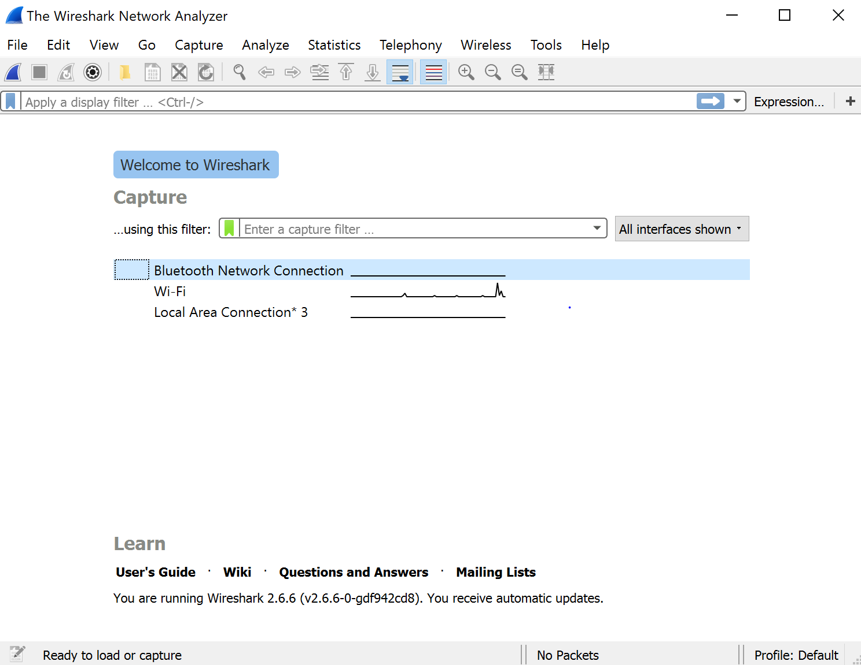

1. Check the packet flow, which interface you are going to use to monitor and capture packets? _______ (**1 point**)

The packet that we are going to use is Wi-Fi

1. Select the suitable interface and star to collect data, get a screenshot of your interface and post it here. You are supposed to see a listing of moving packets. (**1 point**)

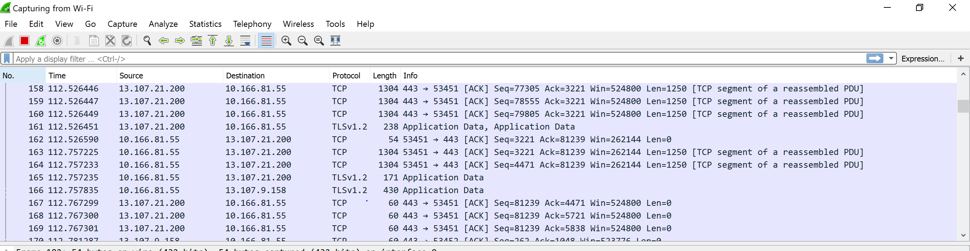

1. Stop data collection from wireshark. Restart your browser (leave the URL box empty). Switch back to your wireshark and click Capture to start collect data. Go back to your browser and enter a URL: Wikipedia.org. Observe the flurry of packets in the wireshark summary window. Wait for 10 seconds, then stop collection. The listing of packets are the communication between your own host and the URL.
2. What is your own host IP address____192.168.1.96______ (you can use windows powershell or other method to figure it out) **(1 points)**
3. What is the Wikipedia.org IP address___ 208.80.154.224 ______ (you can use windows powershell or other method to figure it out) **(1 points)**
4. Select one TCP segment by clicking on that in the summary window. Then explore the selected packet in the detail window. You can see the layer hierarchy in the detail window.

What is the encapsulation type of the current frame? ______Ethernet(1)___ **(1 point)**

What is the destination’s EUI-48 address? _____e4:f0:42:a9:91:b2_________ **(1 point)**

Within the Internet Protocol version 4, what is the value of Time to Live? _____the Time to Live: 128____ **(1 point)**

Within the Transmission Control Protocol, by checking which field, you will know the type of the current TCP segment? ___TCP Segment Len_____ **(2 points)**

What type of the TCP segment is it? ___TCP Segment Len:117_____ **(1 point)**

Insert a screenshot of the details window of your current exploration. **(1 point)**

